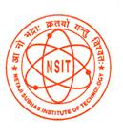

NETAJI SUBHAS INSTITUTE OF TECHNOLOGY

Robust Techniques For Hand Gesture Recognition

Mid Term Evaluation Report 2016



**SUBMITTED BY:**

**RITVIK SADANA, 134/EC/12**

**SARTAJ SINGH BAVEJA, 145/EC/12**

**SHASHANK JAIN, 151/EC/12**

**UTKARSH GARG, 177/EC/12**